Summary Description of LEAD Community of Practice 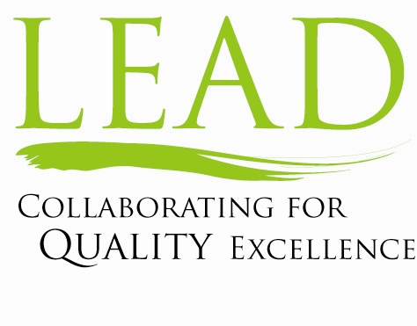

LEAD is a Blue Cross Blue Shield-sponsored program aimed at supporting transformational change in health care in Massachusetts. In late 2006, five health care providers were chosen for their leadership and organizational commitment to quality and safety, and the program ran for 24 months from April, 2007, through March, 2009.

Participants were required to set 3-5 audacious (e.g., theoretical limit) goals for improvement in safety and quality outcomes. In addition, they were expected to engage trustees and hospital/physician leadership through a quality education program, use improvement strategies that required broad organizational involvement, increase physician engagement around safety and quality, and develop new mechanisms for involving patients and their families.

A central element of the program was the LEAD community of practice. The purpose of this community was to:
- Assist and support the CEOS in the learning and leadership of this initiative
- Enable ongoing review and support of progress for each organization and the group collectively
- Create a forum for learning from outside experts.
The community met for 10 one-day sessions per year. The sessions were CEO-focused with no substitutes, and the heads of Quality joined for parts of the sessions.

Each session was hosted by one of the LEAD organizations, and typically also included a featured guest, who would also join for dinner with the CEOs. The typical agenda included: the host organization sharing both a specific improvement example and their overall CEO game-plan for improving safety and quality and current progress; a presentation by a guest speaker – often sharing their own case example; and discussion around a key shared topic – e.g., measurement or physician engagement.

Over the two years of the LEAD program, the CEOs and the heads of quality came to place a high value on the learning and sharing that the community of practice enabled.

